**DAILY ONLINE ACTIVITIES SUMMARY**

|  |  |  |  |  |  |  |  |
| --- | --- | --- | --- | --- | --- | --- | --- |
| **Date:** | **31/05/20** | | | | **Name:** | **Vandana E V** | |
| **Sem& Sec** | **8th semA sec** | | | | **USN:** | **4AL15CS103** | |
| **Online Test Summary** | | | | | | | |
| **Subject** | | **IOT** | | | | | |
| **Max. Marks** | | **20** | | **Score** | | **17** | |
| **Certification Course Summary** | | | | | | | |
| **Course** | **Python for machine learning** | | | | | | |
| **Certificate Provider** | | | **Great Learning Academy** | **Duration** | | | **5 hrs** |
| **Coding Challenges** | | | | | | | |
| **Problem Statement: 1) Python program to find GCD of more than two (or array) numbers** | | | | | | | |
| **Status: Completed** | | | | | | | |
| **Uploaded the report in Github** | | | | **Yes** | | | |
| **If yes Repository name** | | | | **Vandana** | | | |
| **Uploaded the report in slack** | | | | **Yes** | | | |

Online Test Details:

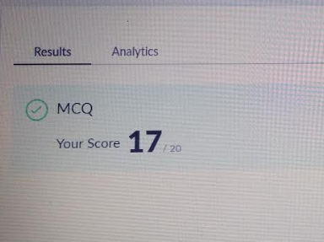

Online Course:

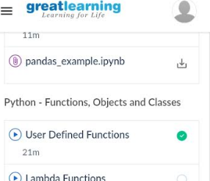

Coding Challenges Details:

def find_gcd(x, y):

while(y):

x, y = y, x % y

return x

l = [2, 4, 6, 8, 16]

num1=l[0]

num2=l[1]

gcd=find_gcd(num1,num2)

for i in range(2,len(l)):

gcd=find_gcd(gcd,l[i])

print(gcd)